**HOW TO FIT A MG*F* BONNET RELEASE CABLE**

The MG*F* bonnet release cable is well known for failing leaving the bonnet locked in the worst case which then becomes a challenge to release from below the car using some long levers. There is nothing that unusual in the design of the cable; the problem is that the latch mechanism is hidden below the ‘bonnet locking platform assembly’ (the panel over the top of the radiator) so rarely receives any lubrication. Eventually the wire strands corrode or fray (or more likely both) and part at the latch assembly. Prevention is much better than cure so it would be worth lifting the bonnet locking platform assembly to take a look at your cable and give it lubrication or replace it if it looks dodgy.

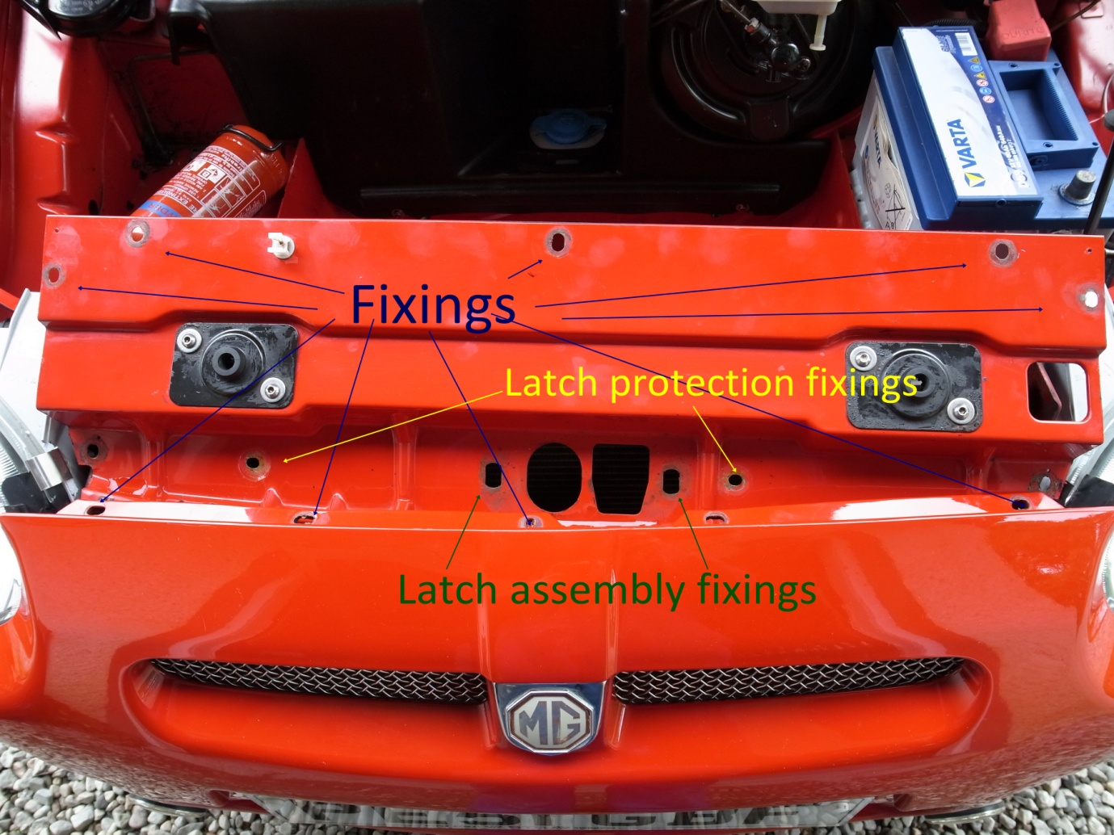

The platform can be lifted by removing the bolts and screws at the positions indicated in blue. Under the platform is a protecting plate with non-captive fittings (yellow) that should be removed for access and the 2 captive bolts (green) loosen the whole of the latch assembly and upper plate.

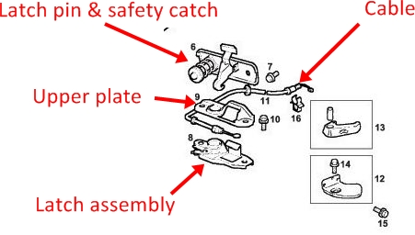

The latch assembly has a ‘guillotine’ fitting which is spring loaded to engage the latch pin. When you pull the cable release in the boot, it pulls back the guillotine and the spring around the latch pin ‘pops’ the bonnet to be held by the safety catch; when the cable parts, the guillotine remains firmly locked.

This shows the guillotine:

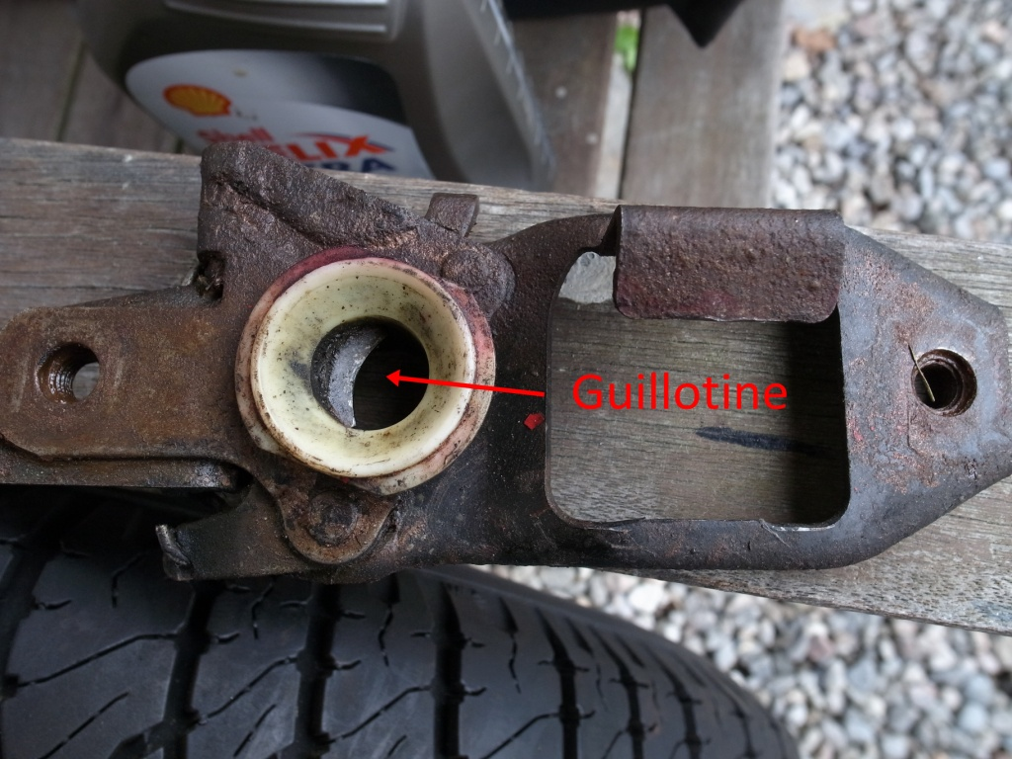

And this is the view of the underside of the latch assembly – you can see the spring and the route for the cable fitting:

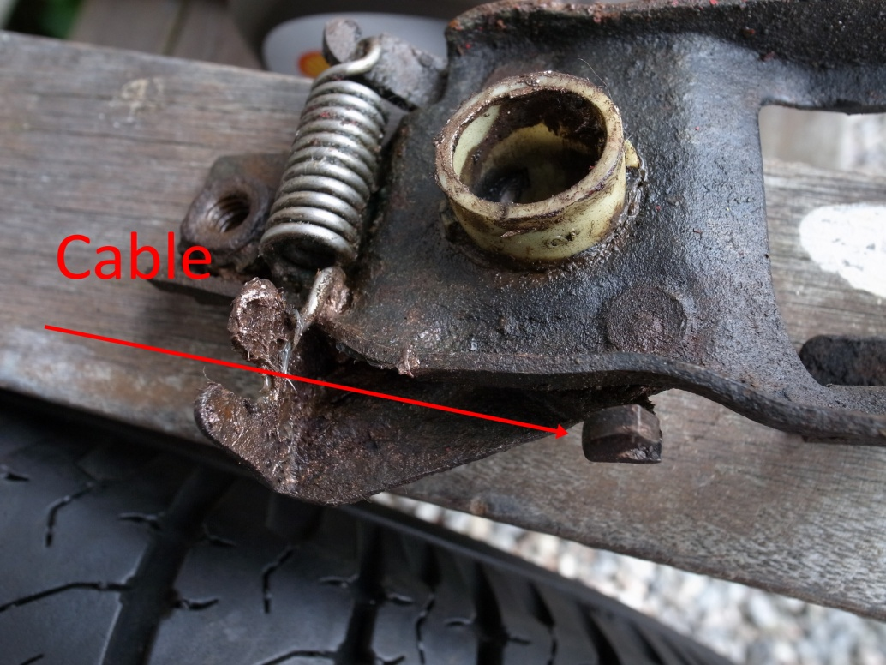

I needed a new cable and the best deal was via the MG Owners’ Club (part FSE000160) and for July 2015 this is on offer at £19.95 with free delivery! The cable (which is longer than the car) comes complete with grommets.

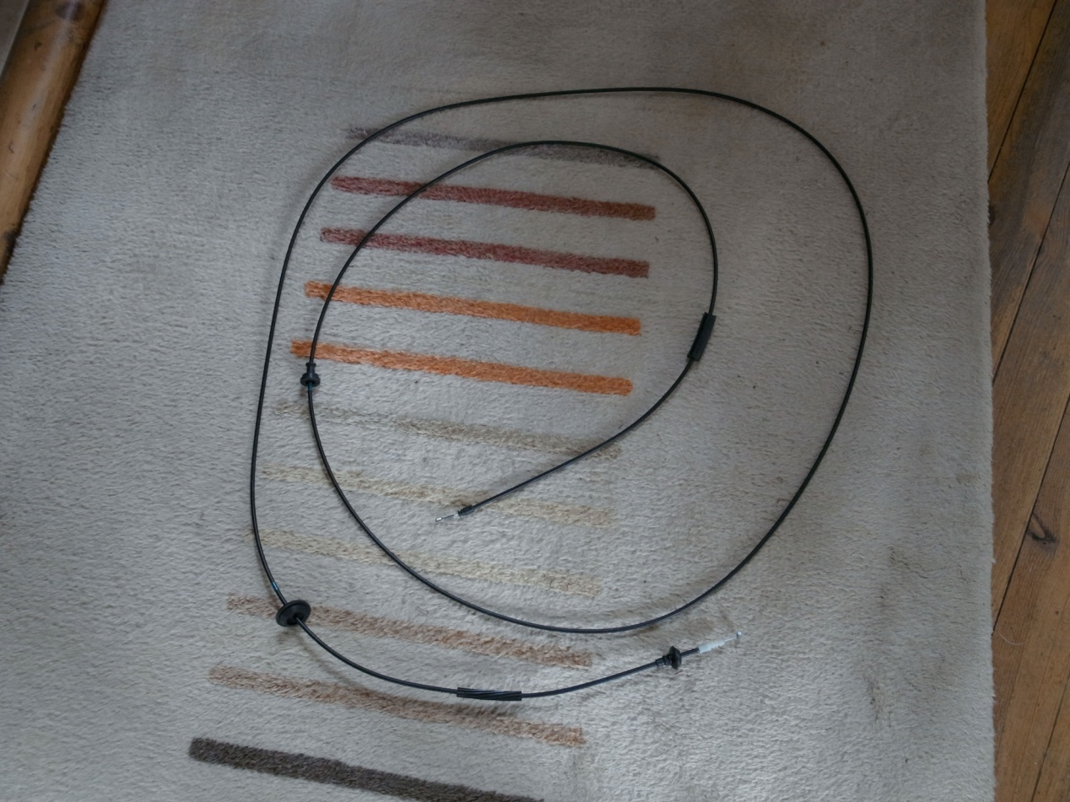

From a routing point of view, starting from the bonnet, the cable exits from the radiator area, runs along the top of the inner right wing before entering the cockpit via the bulkhead near where the electric wires route to the fuse box before running along the right sill under the carpet then up under the T-bar, across the top of the engine cover before entering the boot via the rear bulkhead. From the direction of the grommets I deduced that the cable is designed to be fitted from inside the car working forwards and backwards rather then from one end. It’s worth removing the old cable carefully so that you can identify all the clipping points.

So starting with the driver’s door propped right open, release the carpet trim along the sill to reveal the cable. You will find that the sill is braced with a large plate and the cable routes via this; it’s this plate that makes fitting the new cable difficult with the grommets still attached.

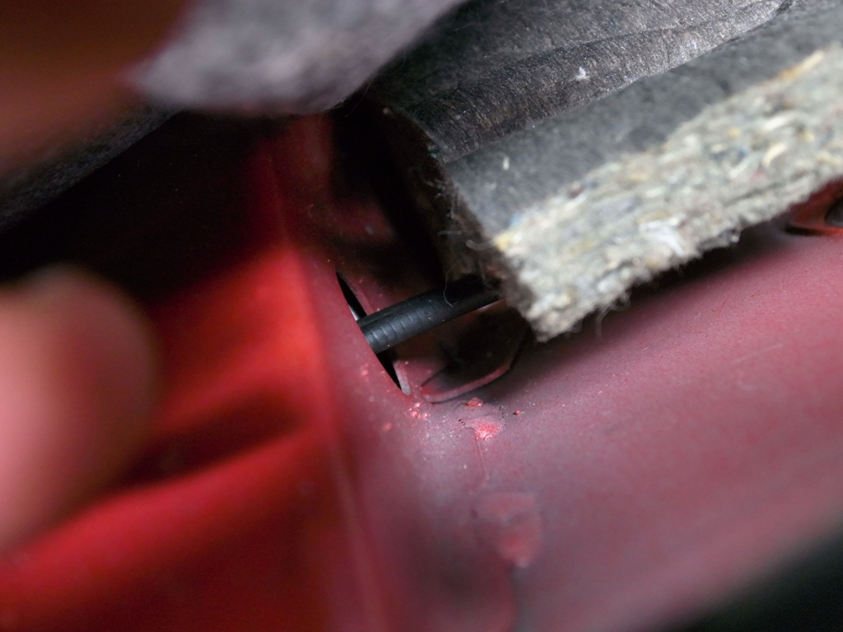

I found it best to remove the old cable by pulling the forward end in to the cockpit via the forward bulkhead. I then undid the bonnet pull in the boot to release the cable and undid the plate that holds the cable cover in place (it’s a simple Bowden cable so the cover or sheath has to be held firmly at both ends to that the cable can slide through it).

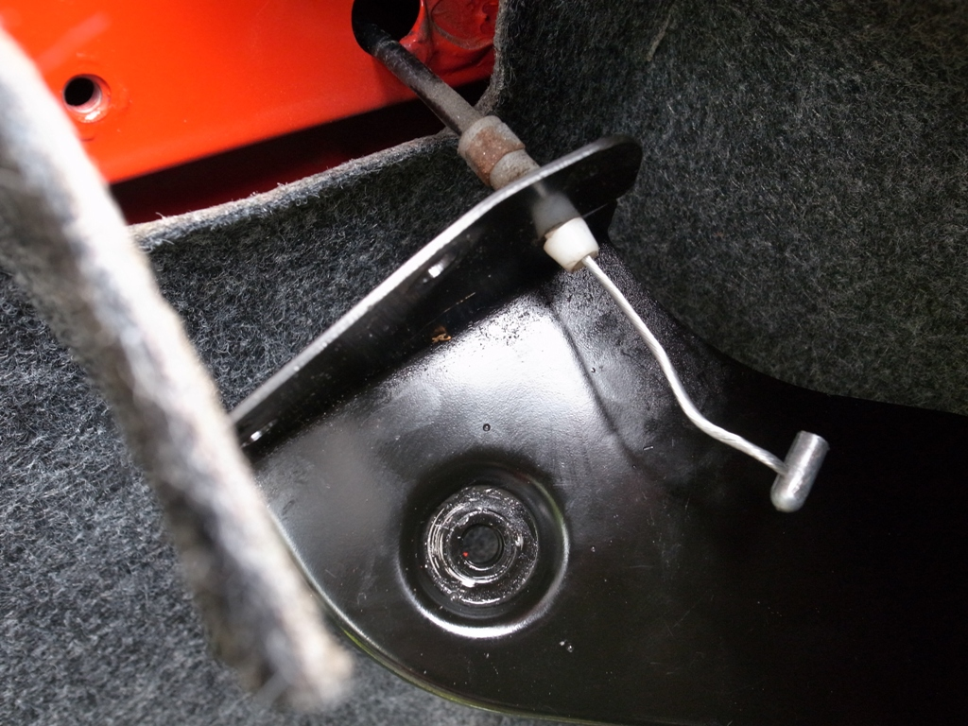

It should then be possible to pull the boot end of the cable in to the cockpit pulling the bulk head grommet with it. This should get you to the point where all of the cable is in the cockpit but still running via the sill brace. As the grommet for the forward bulkhead is smaller in diameter, it made sense to me to remove the old cable rearwards via the brace.

Fitting the new one is simply the reverse…………OK, it’s not totally simple.

I suggest that you feed the bonnet end of the new cable through the sill brace from rear to front then feed the cable via the front bulkhead in to the bonnet area. The position for the grommets is marked in colour on the cable sheath. I found that the bulkhead grommet simply popped-in place when pulled from under the bonnet. Then feed the boot end under the T-bar across the engine cover (easier to do with the rear of the hood undone) then via the rear bulkhead (again the grommet position is marked on the cable sheath) to the boot. Then with the bonnet pull on its side so that the slot lines up, fit the cable end and then the boot release plate to hold the cable captive before attaching the pull.

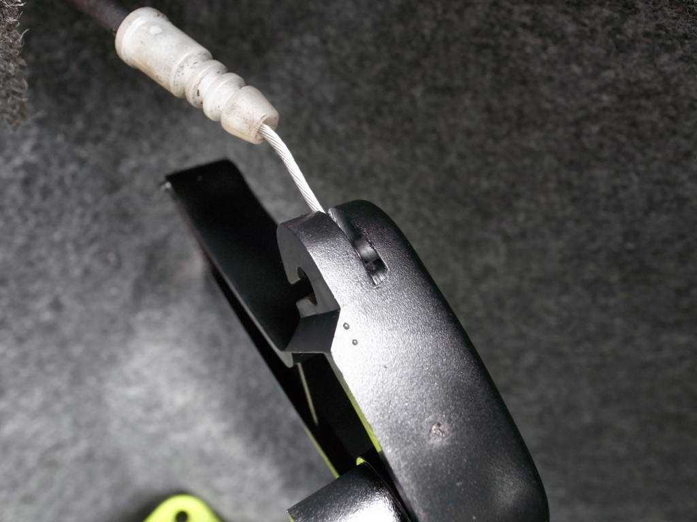

At this point I made sure that the cable was clipped-in all the clips and decided to refit the carpet before attaching the bonnet end.

With everything routed and the cable soaked in oil then grease I clipped-in the sheath to the latch assembly followed by the crimped-on end.

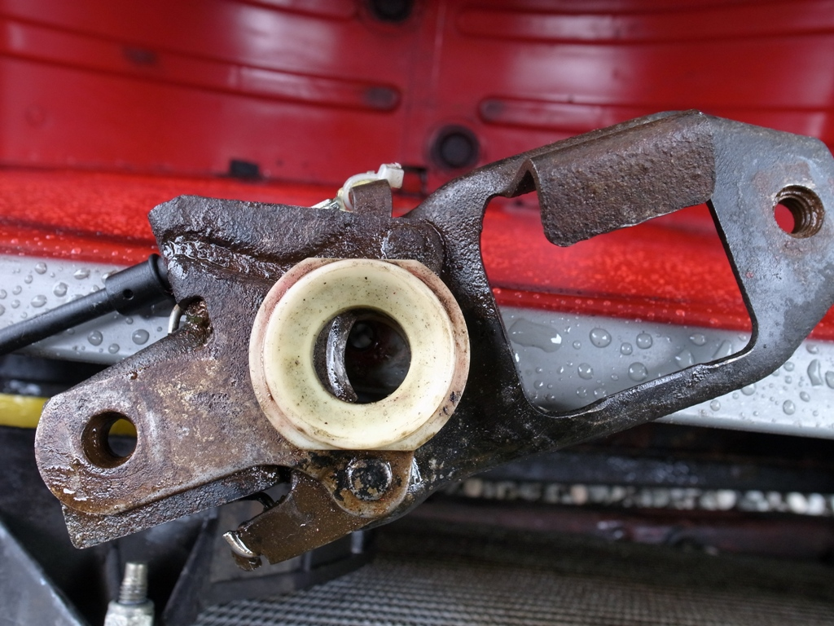

Roger Parker recommends a cable tie here to avoid any chance of the end slipping off – apologies for the poor photo:

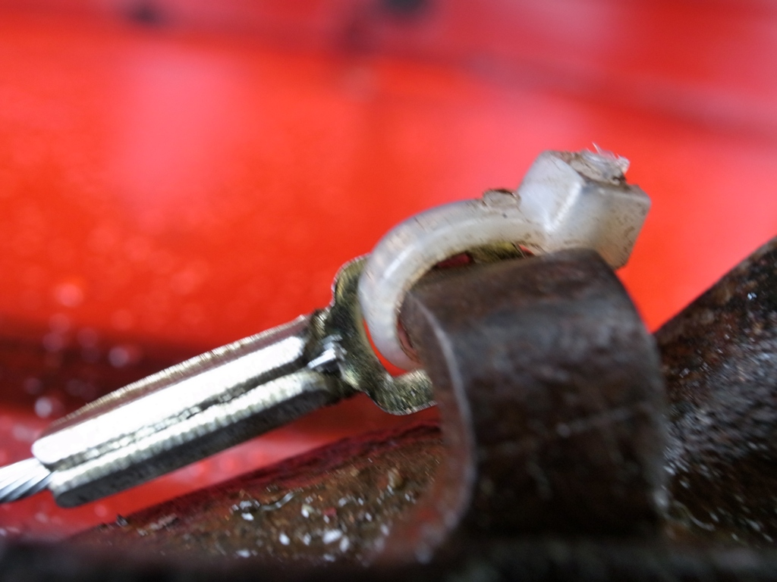

The latch assembly and under protector can be replaced on to the bonnet locking platform assembly before it too is replaced over the radiator**. AT THIS POINT** ask your charming assistant to work the cable pull while you observe the guillotine to make sure that it moves completely out of sight (otherwise you may end-up with a locked bonnet). If this is OK, with the latch assembly slightly loose, gently lower the bonnet so that you can check that the latch and the latch pin are lined-up. **DO NOT** close the bonnet fully yet. When you are happy that the line-up is OK, tighten the latch assembly fixings and then because you are paranoid check the guillotine movement again with your assistant then take a deep breath and close the bonnet! It should open again.

Richard