**Repairing MG F Door locks (2001)**

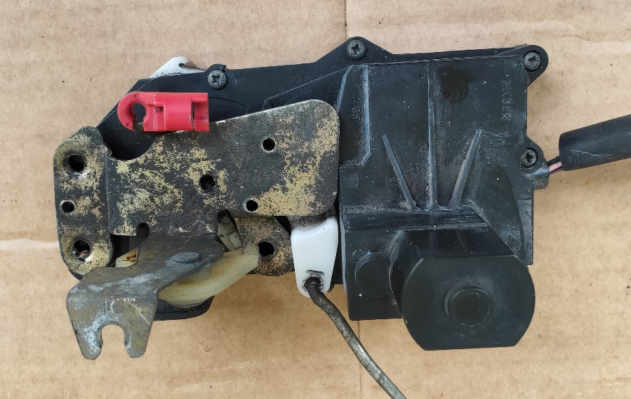

**Problem**

I was locked out of the car, and there were rattling locks.

Eventually the doors opened after numerous times trying with remote.

**Action**

Upon disassembling the locks I found that in both cases there was a fault with the Super Locking Mechanism. One had the Pawl shaft broken and the other had the actuator on the Super locking motor spinning loose (the small motor)

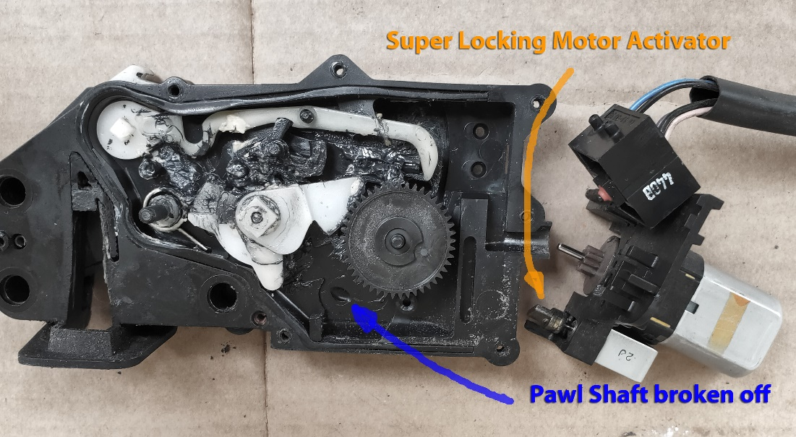

**Repair #1**

Remove the Super Locking mechanism, thus these items were removed

* Spring
* Pawl
* Also the loose Motor actuator.

The Super Locking Motor I left in place.

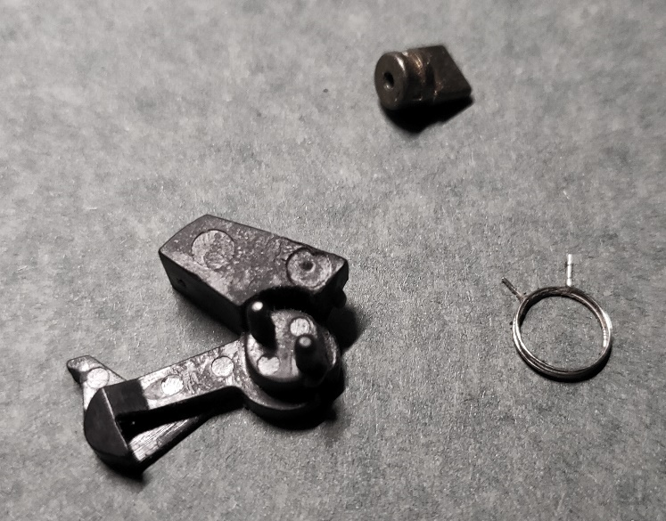

**Summary**

I was then able to Lock and unlock the car using the remote and the key. I was also able to open the doors with the inside and outside door handles

but

When I locked the door using the door knob the car would not unlock as if it was super locked.

**Repair #2**

The main Arm operated by the Locking Motor has 3 positions, Lock, unlock and what I would say was a Super Locking position (see photos below), in this position the Door Knob would freely move up and down without any action.

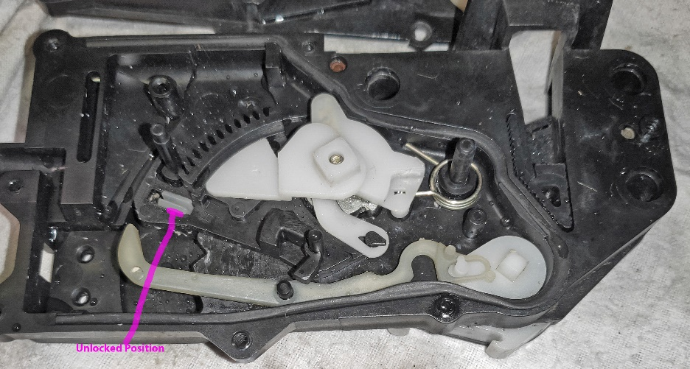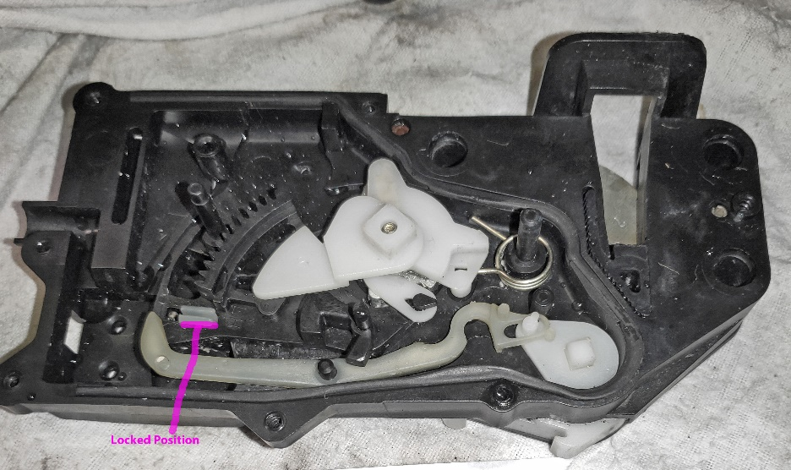

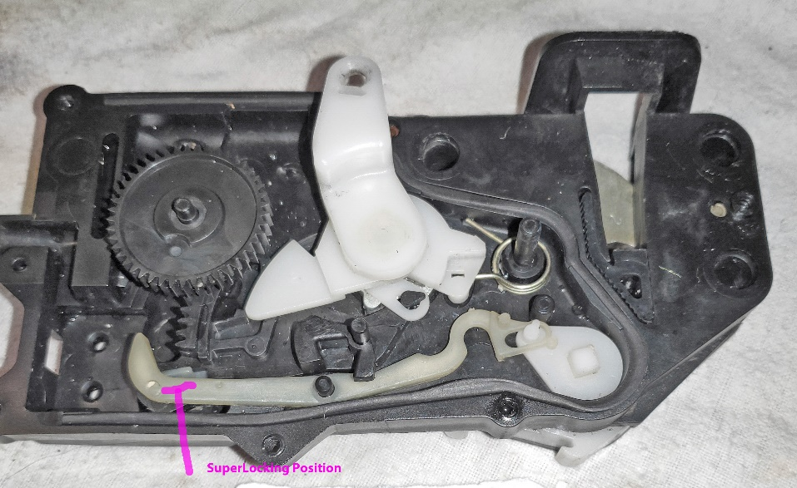

As I had already removed the Super Locking Mechanism, I then restricted the movement of the Main arm by drilling a small hole and screwing in a Screw. There needs to be a slight gap between the Arm and the Screw so that one of the Switches is properly engaged. Now the Main Arm has only 2 positions, Lock and Unlock.

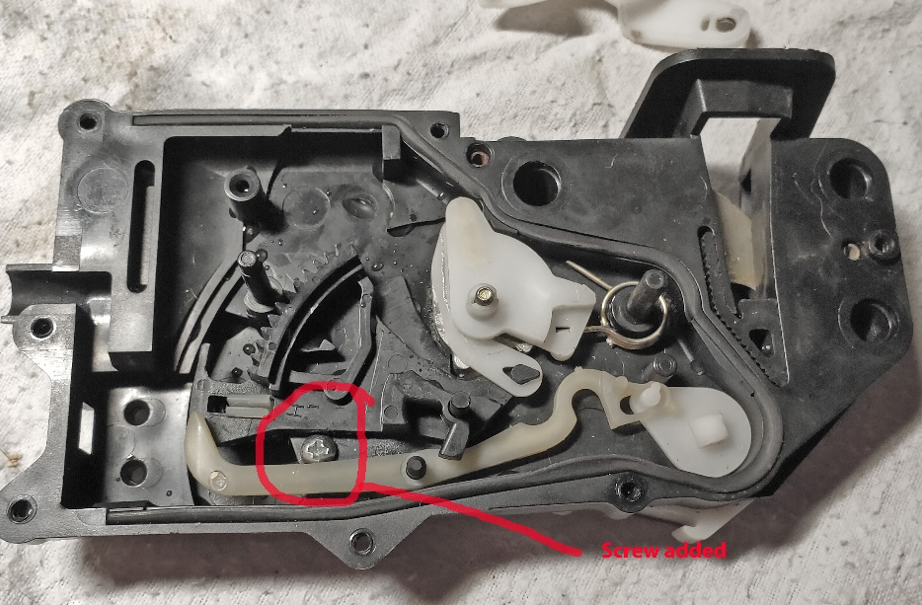

You then just need to add grease and reassemble.

**Warning.**

The Super-locking feature has now been disabled.

If the car is locked and someone breaks in the alarm will sound if the door knob is pulled up.

As such if you are leaving the car with the hood down then it would be better to leave it unlocked, the engine is still immobilised

**Notes.**

The rattling noise may come from a sticking centrifugal clutch mechanism on the Main Motor.

The clutch has a pin that moves out and engages against the loop of the gear. I lubricate the pin to allow it to free move in and out.

